EXPERIMENT 03
PERFORM SESSION HIJACKING USING VARIOUS TOOLS

1. AIM
To understand and demonstrate how an attacker can hijack an active unencrypted HTTP web session by executing ARP spoofing (Man-in-the-Middle) and capturing session cookies using Ettercap and Wireshark.

2. THEORY
Session hijacking involves capturing a valid session identification cookie issued to an authenticated client. By injecting the stolen cookie into their own browser session, an attacker can impersonate the victim without needing account credentials.
ARP Poisoning (ARP Spoofing) sends forged ARP reply packets onto a local network layer, mapping the attacker's MAC address to the IP address of the default gateway. This redirects victim network traffic through the attacker's system (MITM position).
Unencrypted HTTP communication transmits session cookies in cleartext header fields, making them easily sniffable over a poisoned LAN.

3. TOOLS REQUIRED
- Kali Linux (Attacker VM)
- Target Machine / DVWA (HTTP mode)
- Ettercap (GUI Mode)
- Wireshark Packet Analyzer

4. PROCEDURE & COMMANDS
Step 1: Configure Environment & Enable IP Forwarding
Ensure attacker and victim VMs are on the same isolated subnet. Enable Kernel IP forwarding on Kali to forward victim traffic seamlessly:
echo 1 > /proc/sys/net/ipv4/ip_forward

Step 2: Launch Ettercap for ARP Poisoning
Launch Ettercap graphical interface, scan the host list, select the victim IP as Target 1 and Gateway IP as Target 2, then start ARP poisoning:
ettercap -G

Step 3: Capture HTTP Traffic in Wireshark
Start packet capture on the active interface in Wireshark and apply an HTTP filter:
wireshark &
Filter: http.request

Step 4: Intercept and Extract Session Cookie
Have the victim log into the HTTP site. Locate the HTTP GET/POST request packet in Wireshark, expand the Hypertext Transfer Protocol tree, and extract the Cookie string (e.g., PHPSESSID=abc123xyz).
Step 5: Inject Session Cookie and Hijack Session
Open Firefox on Kali, open Web Developer Tools (F12) -> Storage/Application -> Cookies, replace the existing session cookie value with the captured string, and refresh the page to gain authenticated access.

5. LAB OBSERVATIONS & OUTPUT SCREENSHOTS
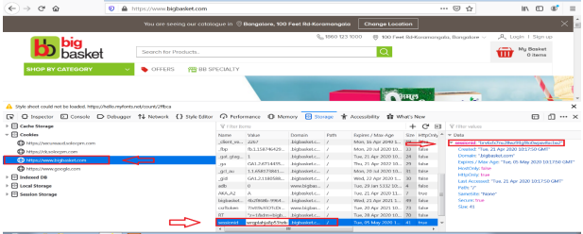

6. EXPECTED OUTPUT RESULT
Successful interception of unencrypted HTTP traffic, extraction of the active PHPSESSID cookie via Wireshark, and verified session hijacking allowing unauthorized access without credentials.

7. VIVA VOCE QUESTIONS & ANSWERS
S.NO & VIVA QUESTION | TECHNICAL ANSWER
Q1. What is a session ID, and why is it dangerous if stolen? | A session ID is a unique token issued by a web server after authentication to track state. If stolen, an attacker can impersonate the victim's authenticated session without knowing their password.
Q2. What is ARP spoofing, and how does it enable session hijacking? | ARP spoofing broadcasts fake ARP responses to link the attacker's MAC address with the gateway's IP. This forces network traffic through the attacker (MITM), enabling cleartext cookie capture.
Q3. Why does this attack work on HTTP but not (easily) on HTTPS? | HTTP transmits session headers in cleartext. HTTPS encrypts transport-layer data using TLS/SSL, preventing simple network sniffers from reading cookie values.
Q4. What is the role of Wireshark in this experiment? | Wireshark captures intercepted raw packets, decodes HTTP headers, and displays plaintext session cookie values.
Q5. Name one real-world countermeasure that would have prevented this attack. | Enforcing full HTTPS with HTTP Strict Transport Security (HSTS) and setting Secure and HttpOnly flags on session cookies.

